New Information is in Blue Text
Event Name | Caldor Fire: 08242021-163
Date | 09/03/2021 1700
Report Number | 12
Duty Officer – 775-687-0498: Rodney Wright
Current Situation
Governor Sisolak has signed a Declaration of Emergency and the Douglas County Board of Commissioners has declared a State of Emergency in response to the Caldor Fire. As of 1300 the containment of the fire is at 29%. Acres burned is at 212,987. Evacuation orders in areas of El Dorado County, California have resulted in road closures and shelters opening within Nevada. Evacuation orders have been issued to Douglas County residents from Upper Kingsbury (South), Upper Kingsbury (North), Central Kingsbury, Lower Kingsbury, Lake Village, and Lower Olivers (Kahle Drive region and roads). An evacuation warning has been issued for Mottsville. Casinos in the South Lake Tahoe area have begun closing some gaming operations, but the hotels and to-go restaurants remain open.
The evacuation order for the Round Hill region was rescinded. The order was issued out of an abundance of caution and is no longer considered necessary.
ESF 1: Transportation |  |  | Duty Officer: 775-888-7645
As of 1900, the following highway restrictions are in place to facilitate evacuations and limit access to affected areas:
- US-50 closed to westbound traffic at Spooner Junction (South Carson St. and US-50)
- SR-207 (Kingsbury Grade) closed to westbound traffic
- SR-28 Closed to southbound traffic from US-50 Junction

NDOT, in coordination with NVNG and NHP have implemented 7 traffic control plans to assist in the evacuation of the Lake Tahoe Basin.

NDOT is bringing in personnel from Las Vegas for standby in the event Foothills road, in zone 2, needs evacuated.
ESF 4: Fire |  |  | Duty Officer: 775-684-2560
Nevada Division of Forestry has personnel, equipment and crews supporting Cal Fire on the Caldor Fire.
ESF 6: Mass Care
As of 0730 on 9/1/21, the current shelter status is as follows:
- Douglas County Shelter is still open
- Carson City Community Center is closed
- Fuji Park is closed.
- Reno Sparks Convention Center opened at 2100 on 08/30/21 with room for 454.
- Dayton Event Center/Rodeo Grounds have room for 100-150 recreational vehicles for dry camping with a limited number of large animals.
- Lyon County Fairgrounds has room for 200 RVs for dry camping with the ability to house large animals.

Red Cross Managed Shelter Updates as of midnight 9/3/2021.
Congregate Shelters
Total Congregate Shelters in NSS: 4 (no change) from yesterday.
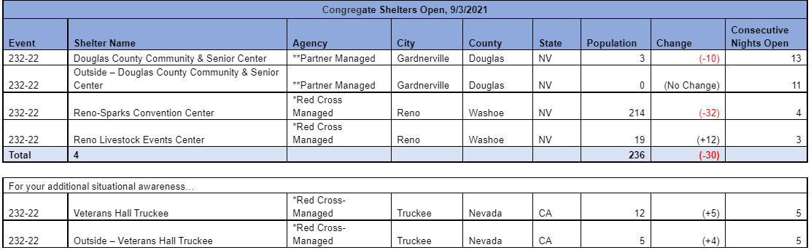

Red Cross continues to manage shelters to support residents affected by expanded evacuations around South Tahoe, CA. Red Cross is currently operating under the planning assumption that approx. 900 individuals would seek congregate sheltering in Nevada (3% of evacuated population). On 9/1 this shelter will expand to a COVID capacity of 908. Red Cross has submitted a resource request to support this shelter with public health staffing, security and wrap around services (shower, toilet, hand wash stations).

In addition to all congregate (indoor) shelter sites, there are individuals residing outside on the premise (tent, trailer or RV) as reflected in the “Outside” count. This population receives wrap-around services but is not reflected in the congregate shelter count, per Red Cross standard operating procedures.

The Reno Livestock Events Center will be closed in four (4) days due to an event. Mass care is working on a solution on the local level.

Pet sheltering is being coordinated at the Reno Livestock Events Center with support from ESF 11.
Mass Care Feeding
Meals Served: 4,652
Snacks Served: 2,652

Mass Care Distribution of Emergency Supplies (DES)
Comfort Kits Distributed in Shelters: 101
ESF 8: Public Health |  |  | Duty Officer: 775-684-5920
Providing COVID tests to shelters and licensure waivers to healthcare workers coming into the state.
ESF 10: Hazmat |  | Rebecca Bodnar: 406-270-6000
Continuing to model critical infrastructure at Kingsbury and Foothills.
ESF 11: Agriculture |  | William Striejewske: 775-846-1165
Pet sheltering is being coordinated at the Reno Livestock Events Center with support from the Nevada Department of Agriculture
ESF 12: Energy |  |  | Lorayn Walser: 775-230-9851
Remain in contact with fuel suppliers and utilities. Fuel inventory is currently strong. Southwest Gas has begun the process of proactively turning off meters for safety reasons to previously isolated and evacuated areas in South Lake Tahoe, CA. Currently 541 customers presently without natural gas service. SW Gas will continue to follow the fire and may undertake additional meter shut offs depending on fire behavior and evacuations.
NV Energy continues to undertake proactive measures to prevent line and power loss. ESF 12, ESF 10, ESF 16, and NV Energy met to discuss transmission routing and potential power interruptions to infrastructure in Carson Valley."
ESF 13: Law Enforcement |  |  | Lt. Tony Roth: 775-720-8518
Nevada Highway Patrol is supporting local law enforcement at evacuation control points.
2 Washoe county Deputies began work in Douglas open resources. Total in Douglas open resources is 3.
ESF 15: Public Information |  |  | Gail Powell: 775-434-4795
Working on a press release regarding the lifted evacuation orders in Douglas county. This will contain content regarding the repopulation efforts including insurance and routes to return home. In addition to releasing this information they are working to make it language accessible in Spanish. They are looking for donations for mental health regarding the incident.

Working on a thank-you to the help and incident effort participants.

Please see the following attachments for donation efforts regarding various agencies:

El Dorado Community Foundation: https://edcf.fcsuite.com/erp/donate/create?funit_id=1792
The American Red Cross: https://www.redcross.org/donate/cm/abc10-pub.html/.
Placer Food Bank: https://donate.placerfoodbank.org/for/pfb?_ga=2.168769441.1692671111.1585586084- 667740226.1583304010
Food Bank of Northern Nevada: https://give.fbnn.org/for/zcjkyj/
Project Camp: https://projectcamp.co/
El Dorado County Animal Services: https://www.edcgov.us/Government/AnimalServices/pages/pet_aid_fund.aspx

Joint Information System has been activated and members have been given assignments. Coordination with CalOES, CalFire and county PIO’s on the California side. Questions for the JIC can be forwarded to 775-687-0395 or communicationrelationspio@gmail.com.
ESF 16: Nevada National Guard |  |  | JOC: 775-887-7200
Nevada National Guard has 75 personnel active in the field providing traffic control in evacuation areas. Working future planning for repopulation dependent on evacuation warnings being lifted.

